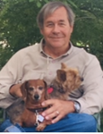
LOREN UTHOFF (1950-2023)
Loren H. Uthoff, Jr. born September 13, 1950, went home to Jesus on May 7, 2023. Loren was born in Tulsa, Oklahoma to Loren and Nona Uthoff. He graduated from Crystal Lake High School in 1968 and went on to receive a degree in Mechanical Engineering from Purdue University. He first worked at the General Motors Proving Grounds and then later for Eaton Corporation as part of the team that developed the super charger. Five years of night school gained him a law degree, and he practiced patent law for Eaton Corporation until he retired.
Retirement brought on new avenues of activities. Loren played softball in both Ohio and Sun City West, he danced, he sang, played in a band, flew RC model airplanes, raced motorcycles, played cards, did lots of reading and more seriously had a deep interest in Christian Theology.
Loren was bigger than life and inspired greatness in us All.
He is preceded in death by his father, Loren Sr.
His wife, Terry, two children, Laura and Andrew, Mother Nona, sister Linda and brother David, stepson, Frank and many grandchildren will deeply mourn his loss.
A mass will be held at Our of Lourdes Catholic Church, 19002 N. 128th Avenue, Sun City West, AZ on Friday, May 19, 2023, at 10:00 a.m.
Retrieved from: https://obituaries.caminodelsol.com/obituary/Loren-UthoffJr
Send Cards and Connect with Terry:
Terry (Theresa) Thomas
14527 W Yosemite Dr, SCW 85375
216.534.6911

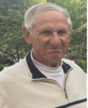
RICHARD "DICK" PRIBNOW (1934-2023)
Survived by his wife of 62 years, Billie, daughter Kelly (Patrick) Oster, son Scott (Nita) Pribnow, grandchildren Emily Oster, Kaylee and Tony Pribnow. Also survived by brother Raymond, sister Jeanette (Jim) Hazzard, sister-in-law Jeanne Pribnow, brother-in-law Dave Hubbard (Terri Hoy), cousins, nieces, and nephews.
Preceded in death by parents Herman and Mabel Pribnow, brothers Robert and Roger, sisters Violet Cote, Bernadette Barlow, and Rachel Hall.
Richard worked for 3M for 38 years in various product development roles. He was located at both the Maplewood, MN and Austin, TX campuses. He retired in 1994 and has maintained friendships with many ‘3M-ers’ throughout his retirement.
Richard was a lifelong athlete who loved to play, coach, and watch sports. He was an accomplished high school athlete and was delighted when he was inducted into the Park High School Athletic Hall of Fame in 2015. The list of sports he enjoyed was long, but most of all he loved watching his kids and grandkids participate in their activities. He never missed a recital or game and always had supporting and encouraging words.
Rich was a quiet man and expressed his love by acts of kindness and helping family members and others. He was always willing to take on a home improvement project to help out his loved ones. His love and generosity will be missed.
Memorials preferred to Park High School Hall of Fame Scholarship Fund (7928 Isleton Avenue South, Cottage Grove, MN. 55016
Proverbs 16:9, The mind of a man plans his way, but the Lord directs his steps.
https://www.tributearchive.com/obituaries/27722415/richard-wayne-pribnow/so-st-paul/minnesota/kandt-tetrick-funeral

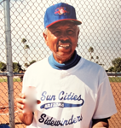
PETE ROQUE (1925-2023)
Pete's brother Art, who also played ball, called to let us know. this sad family news. Pete Roque passed away peacefully in his home on Monday, March 27th at the age of 97. He is survived by his wife, Judy. Pete played tournament ball with Sidewinders.
No services are planned. Let’s send cards to the family and lift our prayers for them during their time of loss:
13058 Ballad Dr
Sun City West, AZ 85375

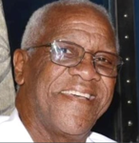
WILLIAM "WILLIE" DOBY (1951-2023)
William (Willie) L. Doby passed away peacefully at his Arizona home the evening of February 12th, 2023. He is survived by his three children William Ryan, Sabrina Ryan, and Derek Ryan.
William touched the lives of many people throughout his 16 year tenure as a security guard at Lowell High School. Celebration of Life will be held on Saturday, April 8th from 12pm-4pm at Mount Pleasant Golf Club, Lowell MA
https://www.legacy.com/us/obituaries/lowellsun/name/william-doby-obituary?id=51557246

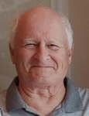
BRUCE STANNARD (1949-2023)
Bruce Stannard (73) passed away suddenly at home on February 22, 2023, in Sun City West, AZ. He is survived by his wife Carol.
He graduated from Ohio University in Athens, OH. He also attended University of North Texas in Denton, TX. He was an adventurer and enjoyed many different jobs in many different states. He became a Christian while in Texas and loved serving at churches he attended as well as making many great friends along the way. He loved cars. His Grandfather, Great Uncle and Uncle owned a Buick dealership in Port Washington, New York, so cars were in his blood. He would travel across the country by car visiting family and friends on his way to North River, New York where the family camp was. Fall time being his favorite time to be in upstate New York. Treasure hunting along the way to anywhere was a must and he was always on the lookout for a good thrift shop.
After meeting and marrying Carol Carr on September 20, 2003, in Colorado, he was ready to settle down. They moved to Sun City West in 2008 where he immediately joined the SCW softball League and enjoyed being a kid again. Along with softball he loved watching sports, and his favorite teams were the Denver Broncos and the Colorado Rockies. Bruce and Carol did a lot of traveling and enjoyed cruising the Caribbean, Alaska and Hawaii. He loved so many things like M&M’s (which he insisted were his vitamins), working on home building projects and going to car shows but the most important thing for him was his love for family and friends. He was always staying in touch by calling or texting someone to check in on them, remembering birthdays, anniversaries, or Pi day. He was a true and faithful friend.
Please come and celebrate Bruce’s life.
April 19, 2023
SWC Foundations Building
Room Webb/Powell
From 2-4pm
14465 RH Johnson Blvd, Sun City West, AZ 85375
In lieu of flowers donations can be made to the following:
Helping Hands
14624 W. RH Johnson Blvd
Sun City West, AZ 85375
Website: www.scwfoundation.org
https://www.obituaries.caminodelsol.com/obituary/Bruce-Stannard
ARC- automobile/Restoration Club of SCW
19803 N. RH Johnson Blvd Building B
Sun City West, AZ 85375
623-518-3226
Website: arcofscw.com

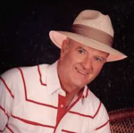
HAROLD "HAL" NOONAN (1927-2023)
After graduating from high school, he enlisted in the U.S. Merchant Marines. He served as a combat veteran during WWII. Upon returning from the war, he earned an Associate’s in Science from the County College of Morris. Hal served in the field of Corrections for 32 years where he retired as the Warden of the Morris County Jail. Hal was a past President of the N.J. County Jail Warden’s Association.
In 1981 he and his wife Catherine Ann (deceased) retired to Sun City West, AZ. During this time Hal volunteered, traveled and enjoyed golfing, bowling and softball. He was a member of the Sun Cities Softball league and played on the team that won the Senior Softball World Series in both 1998 and 1999.
He was a member of the Knights of Columbus 359, the A.M.M. Desert Mariners and Our Lady of Lourdes Parish. Hal is survived by a brother Paul (Anita) in N.J. He is also survived by sons Harold and Kevin (Andrea), daughters Denise (Robert) White, Moureen and Ann (Eddie) Sandoval along with 10 grandchildren and 5 great grandchildren.
There will be a mass of celebration at Prince of Peace Church on Thursday, March 23, 2023 at 10:00AM. A private inurnment will be at The National Memorial Cemetery of Arizona. Donations can be made to Wounded Warriors, Homes for Hero’s or the Disabled Veterans. Please join Harold’s family in sharing memories, pictures or videos on his tribute wall at www.caminodelsol.com.
https://www.azcentral.com/obituaries/par068166
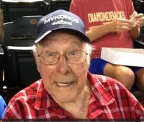

BOB MILLSLAGEL (1927-2023)
Robert F. Millslagel, 95, passed away on January 15, 2023 from complications related to COVID-19. He was born on July 14, 1927 in Peoria, Illinois and graduated from Peoria Manual High School. After graduation, Robert joined the United States Navy during World War II and served as a Seaman 1st Class, and was a veteran of the Pacific Theatre, where he served on the USS Fon du lac. After his service, Robert was a dedicated employee of the postal service for many years before retiring. He was a loving husband to his wife Loura (deceased April 2012) and father to his three children, Jeannette (deceased April 1975), Roberta (married to Roger England) and Michael (married to Teresa Moore). Robert was also a proud grandfather to Leann (married to Allen Walters).
Robert was an avid sports fan, particularly of baseball and the St Louis Cardinals. He enjoyed playing softball in the senior league in Sun City, Arizona and was inducted into the Sun City Softball Hall of Fame.
A private family service will be held in his honor. In lieu of flowers, the family requests that donations be made in Robert's memory to the Angels in the Outfield at the Sun City Senior Softball League.
Make memorial donations to Angels in the Outfield.
Mail to:
Angels in the Outfield
c/o Donna Laufer, Chairman
10445 W Meade Dr
Sun City Arizona 85351
memo line: Bob Millslagel Memorial Fund
The family would like to thank everyone for their thoughts and prayers during this difficult time.
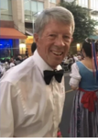

GREGG OWENS (1947-2023)
Gregg Owens passed away on January 21st. (More information coming).
From fellow softballer and friend, Arvid Peterson: "Gregg Owens played softball for many years, was a manager and was inducted into the Sun Cities Senior Softball Hall of Fame in 2014. Many of you will remember his smile and outstanding positive attitude. We are having a Celebration of Life on Saturday, February 18, from 2-4 pm at the Lakeview Rec Center Social Hall, 2nd floor, at 10626 W. Thunderbird Blvd, Sun City, AZ 85351."
Cards can be sent to his wife, Jo at: 10408 W. Bayside Road, Sun City, AZ 85351

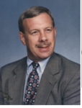
DON ANDERSON (1947-2022)
Donald Anderson, age 75, passed away peacefully on Dec. 29, 2022. He was born in Fremont, Michigan, the son of Carl and Jeanette Anderson.
Donald is survived and missed by his wife of 49 years, Kathy; his children, Kristen (Jeffrey) Carter and Marc (Anna Johnson) Anderson; his cherished grandsons, Brennan and Jaxson Carter, along with several extended family members.
He was preceded in death by his parents and his sister, Carole Wolcott.
After graduating from Fremont High School, he went on to get his BA from Michigan State University. He became a sales rep and account manager for US Steel. His love of MSU showed in his many hats, shirts and jackets that he wore daily. He is fondly remembered for the many tailgates he hosted for his family, cousins and friends.
All enjoyed his sense of humor, sports and music trivia knowledge. In his retirement years as a snowbird in Sun City West, Arizona, Don enjoyed playing senior softball, golf, pickleball and ping pong. He will be missed by his family and friends.
A Celebration of Life to honor Don may be held in the Spring of 2023.
Memorial contributions can be made in Don’s memory to the Alzheimer’s Association, 4081 Cascade Rd. SE Suite 400, Grand Rapids, MI 49546; Association of Frontotemporal Degeneration, 2700 Horizon Drive, Suite 120 King of Prussia, PA 19406 or theaftd.org and the Michigan State Leadership Circle, givingto.msu.edu/loyalty
The family welcomes messages and memories in their online guestbook at www.plaisierfuneral.com.

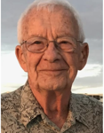
CRIST MILLER (1933-2022)
Crist W. Miller, 89, of Goshen, died on Saturday, August 6, at Goshen Hospital. He was born on February 22, 1933, in Middlebury. On August 13, 1955, in Goshen, he married Viola Miller, Vi passed away on December 17, 2014. On May 19, 2018, Crist married Lucy (Weirich) Yoder, she survives.
Crist and Vi volunteered as Resident managers at Glencroft Retirement Community in Glendale, AZ from 1982 - 1985, and in 1987 moved to Phoenix and worked as Resident managers for Baptist Village Retirement Community in Cave Creek, AZ. After 18 years in Phoenix, they moved back to Goshen in 2005.
Crist enjoyed playing softball for many years, golfing, many driving trips and other travel, and spending time with his family. He will be remembered for living a life of faith in Jesus Christ, generosity, gentleness, and kindness.
Visitation will be from 4:00 - 7:00 pm on Thursday, August 11 at Miller-Stewart Funeral Home, 1003 South Main Street, Middlebury. The family will hold a private graveside service prior to the 11:00 am memorial service on Friday, August 12 also at the funeral home. Services will be conducted by Pastor Craig Garber. Burial will be in Bontrager Cemetery, Middlebury. Memorials may be given to Menno Clinic, India, https://mennoclinicindia.org. Online condolences may be offered at millerstewartfuneralhome.com.
Retrieved from Miller-Stewart Funeral Home, August 6, 2022; https://www.millerstewartfuneralhome.com/obituary/CristW-Miller

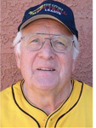
CHET CRAM (1933-2021)
Chester Levi Cram, 88, a resident of Gooding, Idaho and Sun City West, Arizona, passed away on Monday, August 9, 2021, at North Canyon Medical Center in Gooding.
A private family graveside service will be held at the Elmwood Cemetery in Gooding.
Funeral arrangements are under the care and direction of Demaray Funeral Service - Gooding Chapel.
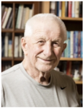

LYLE BAKKEN (1934-2022)
...a long time member of our softball club who served as SCW Accountant for more than 15 years.
Lyle Fred Marvin Bakken, 88, formerly of Drake, ND, died Wednesday, June 29, 2022, in Sanford Health, Fargo, ND.
Lyle was born April 11, 1934, in Drake, ND, to Theodore and Mamie (Vollmer) Bakken. He attended Roosevelt No. Country School until the 8th grade and graduated from Drake High School in 1952, where he played football, basketball, and baseball.
In 1952, Lyle enlisted with the United States Army, proudly serving his country during the Korean Conflict. He was honorably discharged in 1955, attaining the rank of Staff Sergeant. Upon returning home, Lyle attended Dakota Business College in Fargo. Following college, he was employed by Great Northern Railroad and the North Dakota State Highway Department.
Lyle was united in marriage to Maren Rossebo on November 23, 1958, in Trinity Lutheran Church in Drake. Lyle began his banking career in 1959, accepting his first position at American State Bank in Minot, ND. They soon started a family, welcoming their first of four children, Michael in 1959, Nancy in 1960, Derek in 1967 and Kyle in 1969. In 1997, Lyle retired after 38 years in the banking business. Lyle and Maren moved to Sun City West, AZ until February of 2021. While living in Sun City West, Lyle continued his love for baseball. He stayed active playing softball, managing teams and fundraising projects for the softball programs. In 2009, he was inducted into the Arizona Softball Hall of Fame.
Memorial Service will be held Wednesday, July 6, 2022, at 1PM in Trinity Lutheran Church, Drake, ND. Visitation will be one hour prior to the service. Interment will be in the Drake Cemetery.Retrieved from: https://www.korsmofuneralservice.com/obituaries/Lyle--F.M.--Bakken?obId=25273686#/celebrationWall on July 6, 2022

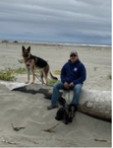
MIKE TOVAR (1963-2022)
Michael Anthony Tovar was laid to rest on Saturday May 07, 2022. Gone but never forgotten.
Mike was raised by Francisco Cantu Tovar (father) of San Juan, Texas who served in the United States Army, and Gloria Cortez (mother) of Ed Couch, Texas, a loving mother and schoolteacher.
Mike was a beloved and devoted husband, loving brother and dedicated father to his children. He worked hard to serve his community with honor and passion through the Human Rights Commission and in Law Enforcement for 27 years. Mike was a man of humility. He rarely asked for anything but always gave his all to anyone - that was his way.
Many know Mike as a sports fan, as he cheered on the Seahawks each season. Mike also found great joy in his brief retirement getting back to playing baseball and watching MLB Spring Training in action. It was something he enjoyed to the core, whether with his wife, friends, family, or getting to know other fans around him.
Michael Anthony Tovar leaves behind his wife Colleen Tovar, his three children; Mike Tovar, Kris Tovar and Bri Tovar, granddaughter Maya Tovar, and his two surviving brothers; Lupe Tovar and Andy Tovar.
Retrieved from: Camino Del Sol https://obituaries.caminodelsol.com/obituary/Michael-Tovar
Colleen Tovar
12834 W Shadow Hills Dr, SCW

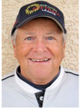
GARY GREEN (1943-2022)
Gary Lynn Green, born Friday, February 26th, 1943, in McKeesport Pennsylvania, passed unexpectedly in his sleep Wednesday May 4th, 2022, in Sun City West Arizona. A Retired Vietnam and Desert Storm Veteran, Gary will be laid to rest at the Arizona National Cemetery in Phoenix, Monday, May 16th, 2022 at 1:30 pm. A loving Father, Grandfather, Brother, teammate, and friend; he will be remembered by many for his friendliness, jokes and stories.
Retrieved from Camino Del Sol: https://obituaries.caminodelsol.com/obituary/Gary-Green

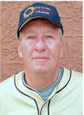
JOHN KELLY (1936-2021)
Kelly, John W. Child of God, died on April 25, 2021, twenty days short of his 85th birthday. Born in Minneapolis, he graduated from Roosevelt High School and the University of Minnesota. He was a skilled and detailed Financial Advisor and generously shared his ability to grow investments to help his family, friends, and many organizations.
John and Carol, his wife of 63 years, made their home in Minnesota, living in Minneapolis, Edina, and Eden Prairie. They spent winters in Sun City West, Arizona for over 25 years. John and Carol enjoyed throwing elaborate Christmas parties, summer camping weekends with friends, and extending hospitality in their home. John was quick to make new friends but treasured his lifelong friends the most. He was very competitive and loved nothing more than playing softball, golf, or card games with his friends and family. As a numbers guy, John was often the scorekeeper, and often the winner! He played softball throughout his life and well into his 80's. He loved playing twice a week with friends when he was younger, and then playing with the Senior Softball League both in Minnesota and Arizona. He was an avid golfer and continued to play as often as he could through last summer.
John was a lifelong member of Holy Trinity Lutheran Church in Minneapolis. He generously gave his financial expertise and assets to the church and took on many leadership roles in the congregation, especially in the areas of stewardship and finance. He was a member of the Southtown YMCA Men's Club for over 30 years and volunteered and led many fundraising campaigns including selling Christmas trees, spaghetti dinners, and pancake breakfasts.
Always curious, John and Carol travelled throughout the U.S. and internationally. He had a fondness for adventure and learning about new places and people. He is survived by his wife Carol who loved and cared for him to the end. daughter Kim (Martin) Rathjen and son David (Kate); grandchildren Rebecca and Kyla Rathjen, Jack, Ryan, and Drew Kelly. A private internment will be held at Fort Snelling. John loved a good party and gathering with friends. It was his wish that such a celebration be held after his death and that we wait to do so until it is safe to gather.
Retrieved from Star Tribune: https://www.startribune.com/obituaries/detail/0000424621/
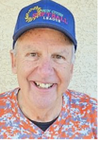
LEE HIRT 1941-2022
Rev. Lee Hirt graduated to glory on March 1, 2022. He faithfully served his Lord and the Methodist church for fifty plus years. He leaves behind his wife, Mary and his children.
A memorial was held on April 2, 2022, at 10:30 a.m. at Shepherd of the Hills United Methodist Church in Sun City West.
Mrs. Mary Hirt
10101 W Palmeras Dr., Apt. 311
Sun City, AZ 85373-3012

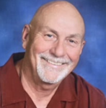
TED MCVAY (1946-2022)
Theodore James “Ted” McVay, age 75, of Sun City West, Arizona passed away on Wednesday, February 9, 2022 while surrounded by his family, at Banner Gateway Medical Center, Gilbert, Arizona.
Ted pursued his dream of playing college football by attending Hutchinson Junior College on a football scholarship after high school and then went on to play football at Kansas State University. He graduated from Kansas State University in 1968 and was drafted into the U. S. Air Force proudly serving his country. Upon being honorably discharged in 1972, he served a brief stint with the Boy Scouts of America and was then offered an opportunity in the banking industry in Nortonville, Kansas in 1975 which led to a lifelong career in the banking industry. He was appointed and elected to numerous leadership roles with the Kansas Bankers Association, Community Bankers Association of Kansas, Bankers Bank of Kansas and other financial institutions over the years. Ted officially “retired” from Farmers State Bank in McPherson in 2012 but continued to serve on the board of directors and in an advisory capacity until his death. Ted was involved in various community and civic organizations in each community he called home.
Sue McVay
McVay Family Foundation c/o Glidden-Edger FH
222 W Euclid St
McPherson, KS 67460

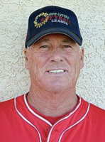
MIKE BURIE (1942-2022)

Michael Anthony "Mike" Burie, age 79, of McFarland, died early Monday morning, Feb. 7, 2022, at Del Webb Hospital in Sun City West, Ariz.
Mike was born on Nov. 2, 1942, on the family farm in rural Columbus, the son of Frank and Luella (Young) Burie. He was a 1960 graduate of Randolph High School and after high school, enlisted in the U.S. Army. Most of Mike's enlisted time was spent in Germany. Mike moved to Madison after returning home from Germany and spent almost his entire career working for the Madison School District. At his retirement in 2000, Mike was Director of Management Information Services for Madison Schools.
Mike and Sandy (McMahon) were married in 1966, and lived in Madison, Sun Prairie, Stoughton and, since June of 2021, McFarland. Mike was an avid sports fan and competitor. He enjoyed playing football in high school and went on to play golf, softball, racquetball and pickleball in his adult life.
Mike also coached 7th and 8th grade football in Sun Prairie for over 12 years. But... golf was his real passion, and he LOVED the game. Mike and Sandy have been members of Stoughton Country Club for over 30 years, and they wintered in Sun City West, Ariz., so they could play golf all year long.
Along with all of Mike's own activities, there was always time to drive to and watch all his children's and grandchildren's many events. His kids and grandkids were the light of his life.
Sandy Burie
15421 N Gunsight Dr
Sun City West, AZ 85375

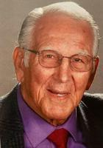
Aprea, Sal ( – 2021 )
SAL APREA, Sun City West American League Softball player and travel team player died suddenly on July 15, 2021. He had been ill from Alzheimer’s for many years. He was a very active person with the Club for many years, but for a while now he did not play.
He loved playing softball and the many friends that he met during his Softball years. Talking with his wife, Ida, I learned that he missed the game.
The family would appreciate any cards or thoughts sent to:
Ida Aprea
14533 W. Corral
Sun City West, AZ 85375
Our prayers and thoughts are with the family.

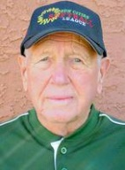
Ballien, Erv (1924 – 2019)
Ervin Wilhelm Ballien of El Mirage, Arizona (formerly of Saginaw, Michigan). Passed away peacefully on Saturday, May 25, 2019, at home. He was 95 years old. Ervin was born January 31, 1924, in Freeland, Michigan to the late Emil and Martha (Reick) Ballien. He married Rose F. Cammarata on June 16, 1984, at St. Matthews Episcopal Church in Saginaw; she preceded him in death on November 30, 2017. Ervin proudly served his country in the United States Army during World War II earning the rank of Tec 5, Infantry. He was the recipient of the Bronze Star for heroism, and the Purple Heart due to injuries he sustained during World War II. Ervin was employed by the United States Postal Service as a mail carrier, retiring after 42 years of service. Ervin enjoyed living in Arizona, playing softball, Square Dancing, and card playing. Surviving is his step- children, Frank Cammarata (Rose), James Cammarata (Claudette), Louise Eaton (Robert), Marie Lamia (James), Paula Cammarata (David Wiblishauser); grandchildren, Erica Murray, Jessica Warzecha (Kevin), Gina Lockwood (Jeff), Elaina Tyree (David) and Frank Cammarata; great-grandchildren, JJ Weiss, Caleb and Landon Lockwood; sibling, June Pinnow, and many nieces and nephews. He was predeceased by his children, Debbie and Matthew Ballien, and siblings, Lilliann, Fletcher, and Eleanor Pinnow.

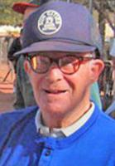
Batow, Phil (1911 – 2014)
Fillmore Glenn Batow, passed away May 8, 2014, after an amazing 103 years of life. He was born March 29, 1911, in Chicago, Illinois. He lived with his family in the Evanston, Illinois, area from 1958 until retiring to Sun City West, Arizona, in 1979.
Beloved husband of the late Loretto Haugh Batow, Father of David (Patricia) Batow, of Tulsa, OK, and Nancy (Dale) Stewart of Roberts, WI. Grandfather to Rebecca and Timothy Batow, Robert and Sarah Strom, and Ryan (Lindsay) Stewart and Great grandfather to Declan and Finley Stewart.
Phil played ball most of his life, most recently with the Sun City National League until he retired from the game at the age of 98, in 2009. He bowled regularly until the age of 101, in Sun City West.
He was blessed to have so many life experiences in his 103 years and he will be greatly missed.

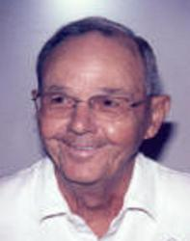
BILL BROMELY
BILL BROMLEY DECEASED
Bill was born August 31, 1933 in Danville, Illinois.
Pitched baseball and softball in grade school, high school and the Air Force.
He also pitched softball in summer and church leagues in Sterling, Illinois.
A member for 15 years Bill’s contributions to the league have been many!
Bill was responsible for the food, entertainment and MC for the first 2 indoor league banquets.
He served 2 terms on the softball board. On his first term he was responsible for uniforms and their distribution, Bill also made schedules for both umpires and scorekeepers. He ordered and assisted in the installation of the mats that are under the batters box which prevent us from digging holes when we all step in to hit.
He was the field manager at Sun City West and was instrumental in having additional doors put in each dugout. Prior to this each dugout only had one opening. Along with others Bill helped to start the National League. he made the motion for a trial and needless to say the rest is history.
During Bill's second tour of duty on the board he once again had responsibility for the condition of the field as well as serving as the Special Events Director, examples being assisting in setting up the Fireman's Day Charity games, All Star Games, etc. He has always been and continues to be willing to help make our league and club better.
His true claim to fame however is in his abilities as an inventor. Yes, Bill Bromley, invented the spare ball holder that is used to accommodate the infield ball as well as the extra ball behind the plate.

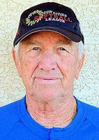
Boinski, Steve “Bo” (1928 – 2020)
Stephen R. “Bo” Boinski, age 92, of Dyer, IN, passed away peacefully Tuesday, December 22, 2020. Loving husband of the late Darlene Boinski, nee Schultz. Devoted father of Andrea (Michael) Pollack, Steven Boinski, and Michael Boinski. Proud grandfather of Jennifer (Tony) Sanchez, Angela (Fritz) Zeher, Amanda (Nick) Sadzak, Sherri Rae, and the late Jason Begonia; great-grandfather of 8. Dear brother of the late Sally (late Ted) Retkowski. Preceded in death by his parents Frank and Cecelia Boinski.
Visitation Monday, December 28, 2020, from 4:00 – 7:00 p.m. at Smits Funeral Home 2121 Pleasant Springs Lane (Rt.30/Pleasant Springs Ln.) Dyer, IN. Funeral Mass Tuesday, December 29, 2020, at 10:00 a.m. directly at St. Maria Goretti Catholic Church (Masks Required) 500 Northgate Dr. Dyer, IN, with Rev. Charles Niblick officiating. In lieu of flowers, please consider a donation to St. Jude Children’s Research Hospital (5501 N. Cumberland Ave. Chicago, IL 60656), in Memory of Stephen.

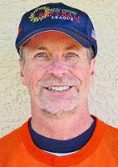
Borho, Peter (1949 – 2019)
Peter passed away on October 10, 2019. He had just turned 70 a little over two weeks earlier.
Peter was one of a kind. He was frequently described as “vibrant.” He had a goofy, contagious smile, and loved to make people laugh. He had a real lust for life and love for friends and family. He leaves behind a hole in many hearts and will be deeply missed.
Peter led a rich life. He loved to play sports. He even met his wife at a volleyball tournament, and later proposed to her over the loudspeaker at a volleyball game. He especially loved softball, and played on teams in Portland and Redmond, Oregon, as well as Sun City, Arizona. His softball family gave Peter much joy.
His love of adventure led him to travel quite a bit. Highlights included trips to Fiji, Tahiti, Australia, and New Zealand. He was especially fond of his experiences skydiving and rafting down a 21-foot waterfall in New Zealand. He also loved to bike. Many adventures were related to participating in Cycle Oregon, Bridge Pedal, and biking on vacations.
Peter served in the Navy from 1969-73 at the Naval Air Station North Island in Coronado, CA.
Peter had many jobs in his lifetime. He relished telling people he had been a grave digger, and often told stories about his days as a traveling photographer. His main jobs were working as a hardwood floor manager, and at the Department of Motor Vehicles, where he primarily served as a manager and lead worker for nearly 20 years. He enjoyed working part time at ACE Hardware for several years after retiring.
Peter was born on September 21, 1949, in Warren, Ohio and grew up and lived in Portland, Oregon for most of his life. He was preceded in death by his late parents, James Borho and Marie Borho, brother Mark, and brother-in-law Joe Walyer. He leaves behind his beloved wife and friend for life, Lisa (Plummer) Borho, and three siblings: Janet (Borho) Walyer, Paul Borho (Barbara Ortega), and Timothy Borho (Sue Borho), as well as niece Sabrina (Walyer) Sheehy (Scott Sheehy), and his beloved great nieces Julia and Celia, whom he adored as if they were his own grandchildren.
Services will be held at 4:00pm MST on Saturday, November 9, 2019, at Sun City Christian Church. The address is: 9745 W Palmeras Drive, Sun City, AZ 85373. Casual attire is encouraged. Please celebrate his legacy by wearing shorts, Hawaiian shirts and bright colors. There will be a dinner provided after the service, at which time we can share stories about Peter. Peter in life loved bright colors and Hawaiian shirts. His wife has requested that anyone attending the memorial please RSVP to her as a dinner will be served after the service and if attending, please be bold in your color choice, no black.

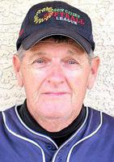
Buxton, Bill

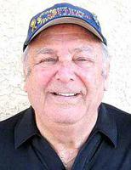
Check, Bob

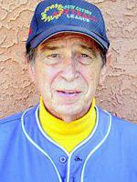
Chervinko, Eugene “Gene” (1929 – 2017)
Eugene J Chervinko, 87, passed away peacefully on January 21, 2017, in Sun City, Arizona. He was born in Wilt, Illinois. Gene was a Certified Public Accountant. He worked for the Sears & Roebuck Company. Gene also loved to play softball. Gene is survived by his beloved wife, Marcella, and his stepson, Bill. A graveside service will be held on Thursday, February 2, 2017, at 1:30pm at Sunland Memorial Park, 15826 Del Webb Blvd., Sun City, AZ 85351.

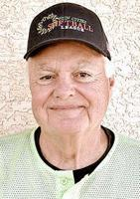
Conley, Bob (1953 – 2020)

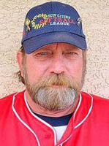
Conn, Wayne

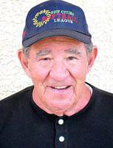
Conolly,Al (1930 –2021)
AL CONOLLY, long-time softball player in Sun City, passed away on January 27, 2021, in Colorado from the Covid-19 virus.
He had been in a Nursing Facility, then hospital since Jan. 14th. He also had dementia and had been on dialysis.
Christy, his wife has asked for anyone who remembers any stories from Al’s softball days to please send to her so she could share these stories with Al’s grandson. There are to be no services because of Covid.
Your stories and prayers can be sent to:
Christy Conolly
2621 W. 110th Ave.
Westminister, CO 80234
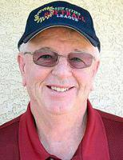
Coumont, Frank (1943 – 2018)
Frank Caumont, 75, Sun City West - 7/30/1943-11/15/2018. He grew up in Spokane, WA. Frank worked in the grocery industry for more than 40 years and coached women's softball for more than 35 years.
Frank was predeceased by daughter, Dina McVey. Is survived by his wife of 52 years, Dee; son, Brian (Rhonda); and granddaughter, Makenna McVey.
A Celebration of Life will be held at Liberty Softball Field Saturday, January 12, 2019, beginning at 3:00 P.M. in Sun City West. The family invites all to attend and share some "Frankisms".

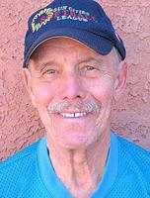
DiBiasio, Tony

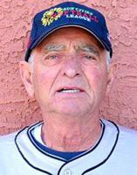
Difore, Joe

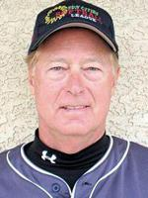

Dobbins, Bob

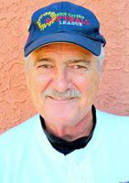
Dorian, Ken (1944 – 2017)
Ken, 72, passed away suddenly on April 14. He was an active and loved member of the Sun City community for 17 years. Ken moved to Sun City from Alsip, Illinois, where he served as a respected Police Officer for 28 years. He was the son of the late William and Tillie, brother to the late Thomas and Dennis. He is survived by his wife Cynthia; brother Timothy (Mary); sons David (Dawn) and Daniel (Shelly); grandchildren Danielle (Richie), Dana, Delaney, Dylan, and Colin; stepsons Mark (Laura), Paul, and Brad; step-grandchildren David and Elizabeth. Ken will be greatly missed. Visitation will be 1:30-2:30 p.m. with service at 2:30 p.m. Wednesday, April 20 at the Lakeview United Methodist Church, 10298 W. Thunderbird Blvd., Sun City, AZ.
Published in The Arizona Republic from Apr. 19 to Apr. 20, 2016

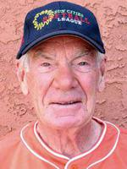
Downs, Dick (1929 – 2017)
Dick, 88, of Sun City West, Arizona passed peacefully on Wednesday, May 17, 2017. Dick was born on May 6, 1929 in Titonka, Iowa to Homer and Ethel Downs. He graduated from Titonka High School in 1947 and from the University of Northern Iowa, where he earned his Bachelor of Science Degree in education, in 1951. He then served in the United States Air Force from 1951-1955. After the Air Force, he began to work on his Master's Degree at the College of Puget Sound, where he met his future wife, Agnes. They married July 21, 1956 and moved to Iowa. While working as a teacher, Dick spent several summers taking classes at the University of Iowa and, in 1969, earned his Masters of Arts Degree in Counseling. Dick started his dedicated career in education as a high school biology teacher and taught driver's education in West Liberty for 4 years. He taught in Cedar Rapids and later moved to Mason City where he was a principal of Wilson Elementary, Director of Pupil Personnel Services, Special Education Director, and later a High School Counselor at Mason City High School where he retired. After retirement, he and Agnes moved to Sun City West where they have resided for 22 years.
Dick loved to watch and read about magic. He even tried a few magic tricks in his life. Dick was a woodworker and used his talent to refinish antique furniture, as well as make many items for family and friends. He was also an active athlete throughout his life. In high school he played baseball and basketball. After meeting his wife, he learned to play tennis and was an avid player until he was well into his 60’s. After retirement he spent more time golfing than playing tennis and, like many golfers, was never happy with his golf game. While living in Sun City West, AZ he played in a senior softball league. He played the position of pitcher in the senior softball league until he was 87 years old. He also loved to ride his bike and enjoyed many RAGBRAI trips across Iowa with friends and family. He and his wife loved to travel and spent many summers in Utah. The highlight of their traveling was to see family in Colorado, Idaho, and Iowa. Richard always enjoyed sitting around talking with friends and family.
Dick was a loving husband, father, grandfather, son, brother, uncle, and friend. He will be dearly missed by all of his family and friends. He is survived by his wife of 60+ years, Agnes Downs and their 4 children; Susan Downs of Davenport, Iowa, Linda Downs and her partner Jim Junker of Manly, Iowa; Karen (Downs) and Dan Tallman of Bettendorf, Iowa, and Bruce and Kristen (Reiber) Downs of Portland, Oregon. Six grandchildren: Lydia, Gavin, Colin, and Liam Downs, and Jacob and Tabitha Tallman. A brother, Robert and wife Nancy Downs of Oelwein, Iowa along with numerous nieces and nephews. He was preceded in death by his parents, Homer and Ethel Downs.
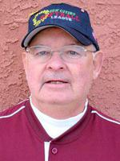
Dunning, Rich

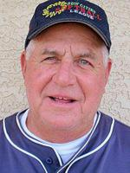
Eckardt,Eddie ( – 2021)
Eddie a long-time Sun City West Softball player, passed away at his home, Friday, September 10, 2021, with his family about him.
Eddie this past year had been having many medical issues and all that played hard on his body. He will be missed by many. Our prayers and thoughts go out to his family.
Your cards can be sent to: Kathy Eckardt, 14701 W. Horizon Dr., Sun City West, AZ 85375

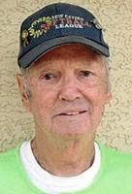
Eppley,Ron (1938 –2017 )
Ronald Jay Eppley passed away peacefully on July 13, 2017 at his home in Sun City West, AZ after valiantly battling cancer for three years. Ron was born on May 9, 1938, in York County, PA, where he lived until he joined the U. S. Air Force in 1957. He only intended to serve for a single four-year tour but when the Cuban Missile Crisis hit he extended for another year. 30 years after he enlisted and many moves around the world, he retired with the highest honors as an E-9, Chief Master Sergeant in 1987. Not being done serving his country, he then accepted a position as a civilian working for the Air Force at Davis-Monthan AFB in Tucson. After 12 years stateside, he and his wife decided one more tour overseas was needed before retirement and off to England and Germany they went for 3 more years.
They settled in Sun City West in February 2006, and on move-in day, Ron was playing softball. These 11 years have been his fondest memories with a bunch of great and fine softball and racquetball players. His friends and teammates were among his most cherished companions.
He gave of himself and his time selflessly and almost always with a smile. Ron is survived by his wife, Karen and their 4 children: Richard & Amy Eppley, Greeley, CO, Deborah & Morgan Dowling, Waynesville, MO, Robin & Gene Jones, San Antonio, TX, and Dianna & Ty Newport, Ahwatukee, AZ.
He was preceded in death by a son, Randy Eppley, his brother, Raymond Eppley, and both his parents. He is also survived by 19 grandchildren, 19 great-grandchildren, 1 great-great-grandchild, and his sister, Rita Streett, Stewartstown, PA. His wife, Karen & his family want to thank Ron’s many friends and cohorts that he has had over his lifetime, both in the Air Force and retired life. He is remembered, especially by Air Force friends, with the motto “you prepare, you do, and you put away.” Ron preferred “no big deal” to be his final thought. In lieu of flowers, the family requests donations to The American Cancer Society (www.cancer.org), to help end all cancer or to St. Jude Children’s Research Hospital (www.stjude.org) where Ron and Karen have always supported. Prayers for Ron and his family are greatly appreciated.
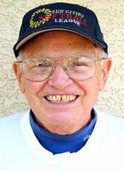
Eriksen, Dick

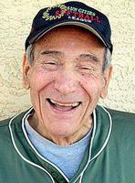
Fanto, Vince (1928 – 2019)
A United States Army Veteran passed away on April 06, 2019, in Scottsdale, Arizona. He was preceded in death by his parents, Joseph Fanto and Theresa Sabatino Fanto; and his beloved wife, Francine R. Fanto. He is survived by his loving children and grandchildren.
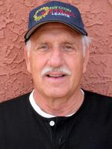
Freeman, Bob

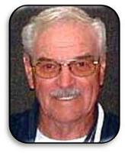
Gault, Don (1935 – 2021)
Don was a long-time softball player in Sun City suffered a stroke on 1/13/21 and after several weeks he passed away on 2/19/21. He was 86 years old. When he played, he was part of the Sidewinders group.
His son, Mike, has requested no cards or calls.
Our prayers and well wishes go out to him and his family.
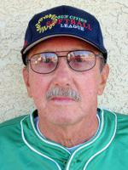
Gay, Louie

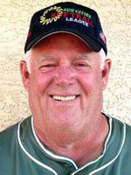
Goldspink, Bill (1946 – 2018)
Bill Goldspink, 72, was born on September 9, 1946, and passed away on November 16, 2018, He was very active in the Senior Softball program in Sun Cities Senior Softball program. Serving on the National League Committee. He also managed the National League team, Royal Oaks and played first base for them until his untimely death.
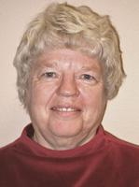
Graham, Linda

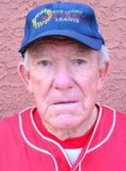
Griswold, Steve (1922 – 2018)
A native of Montana, long-time resident of Sun City, Arizona, and retired school teacher and coach, died Monday morning, October 29, 2018 at the age of 96. He was known for his love of sports and was still playing basketball and softball into his nineties. Published in The Arizona Republic on Nov. 4, 2018
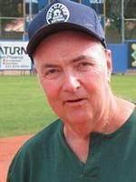
Grumbach, Carl

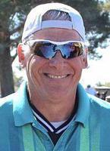
Haarbauer, Marc "Hollywood” (1952 – 2021)
MARC HAARBAUER, American League player from Sun City passed away from Covid-19 on January 22nd.
He is survived by his Life Partner, Melodie and his two daughters Kaley and Nicki who reside in Wisconsin but are here until next week.
He is being cremated and his family plans a Memorial Service in the Spring here in AZ.
Marc “Hollywood” Haarbauer, 68, of Sun City, Arizona passed away peacefully surrounded by his loved ones on January 22, 2021. He was born in Waukegan, IL on August 7, 1952. He was the son of Frederick Haarbauer and Mary Haarbauer (Priller). The family later moved to Kenosha, WI where Marc attended Tremper High School graduating in 1970. Marc briefly moved to Colorado before returning to Wisconsin. Marc went onto a local technical college where he obtained a degree in Accounting. He worked as an accountant in the Kenosha, WI area at GRC, Brewmaster’s Pub, Tirabassi Felland & Clark and spent the remainder of his career at Todd’s Companion Plus. Marc moved to Sun City, AZ in December of 2015 where he lived out the rest of his days.
One of Marc’s biggest accomplishments was being a father. He married Joan (Dolnik) Haarbauer in 1992, the couple later split but resulted in his two daughters. He had always wanted children and considered himself lucky enough to have two. His children, Nicole and Kaley, called their dad a superhero, and even as adults, still see him that way. He was always there for them through their ups and downs and taught them to enjoy every moment life has to offer.
Aside from his love for his daughters and family, Marc loved the game. He was an avid Dallas Cowboys fan. Marc umpired local Kenosha softball teams for many years, played in a bowling league, played golf regularly and since moving to Sun City, Marc got back into playing softball. Marc had many close friends and was liked by everyone. He was always matching head to toe. This is how he gained his well-known nickname of “Hollywood.” He was a kind and loving person. Marc was the type of person who could light up an entire room.
Marc is survived by his two daughters, Nicole and Kaley of Kenosha, WI. His brother, Scott (Merle) Haarbauer, of Pleasant Prairie, WI. His three grandchildren: Scarlette, Thea and Bryce and his friend, Mel.
Marc was an astounding father, brother, friend, and pop pop. He will be missed by many.
“And think of him as living.
In the hearts of those he touched,
For nothing loved is ever lost,
And he was loved so much.”
A Private Celebration of Life will be held at a later date
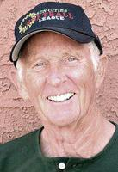
Harrison, Jack

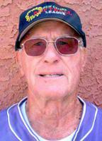
Herren, Bud

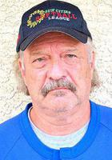
Heuett, Larry

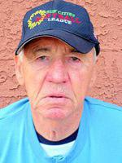
Hill, Bill (1930 – 2018)
Bill passed away peacefully at home in Sun City West, AZ with his devoted wife, and best friend, Karen at his side, just as she had been for 36 years. He is also survived by his brother, Robin Hill; three children, Terrie Bolling, Dan Hill and Nancy Wright; Karen's daughter, Kaye; and numerous grandchildren and great-grandchildren. Bill was born in Kelso, WA to Mary and Vernon Hill. He graduated from RA Long, and married Patty Saunders soon after that. They had three children during their years together.
Bill served in the Navy, and then graduated from Western Washington University with a BA in education. He taught history and coached basketball, and his career took him to Benton City, Zillah, Lake Stevens, and Battle Ground. He took multiple teams to the state playoffs, and one even played for the state championship. He had winning records all 10 years at Battle Ground. In 1972 he created Tiger Cage Camp, the first basketball day camp in the state. Bill also coached basketball at Clark College. He finished his career at Prairie High School. Bill was inducted into the Battle Ground, and the state Hall of Fame, for all of his coaching accomplishments and contributions.
During Bill and Karen's 36 years together, they had a great life. Their favorite activities included fishing, running, playing basketball, playing softball at Sun City West, and watching the Mariner's. Anything that they did together, they always enjoyed. Bill was a unique man, a real character. He was a role model who left a lasting effect on those who knew him. He was loved and respected by his family, students and players. He had a bond with many of his players that has lasted to this day. For years they have come to visit their beloved coach. Last summer, one of his players from Lake Stevens visited Bill. He gave Bill a big hug and said, "Billy, I love you.", a testament to his lasting effect on his students, players, and family alike.

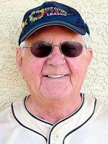
Horner, Wesley

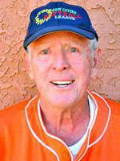
Johnston, Greg (1933 - 2011)
Captain Greg R. Johnston, U.S.N.R., Ret., 78, of Sun City West, AZ, passed away on Friday, August 12, 2011. Raised in Chicago, Greg was a pilot with the U.S. Navy for more than 25 years. He was a member of the Diamond Club Charitable Organization and worked spring training in Peoria for 14 years. He played softball with the Sun City West Men's Softball League and the Over 70's League for many years.
He is survived by his wife, Dolly; daughters, Karen (Kennedy) and Gail (Seth); four grandchildren: Kate, Payton, Jack and Harper; four step-daughters: Susan, Carolyn, Tara and Kate and their children, Jessica, Phoebe, Emma and Aidan.
A memorial celebration of Greg's life will be held at a later date.

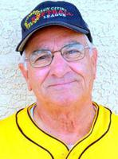
Karras, George (1931 – 2010)
George Steve Karras of Sun City West, AZ, loving husband, father, and grandfather went to be with the Lord on September 6, 2010. He was born in Cleveland, OH on March 16, 1931 to Steve and Sophia Karras. He and his wife Shirley, childhood sweethearts, were married for 57 years. In 1991, George retired from Bostwick-Braun after 25 plus years of service. He was an avid lifelong baseball and softball player. He was active with the Sun City West Softball Club and in 2008 was elected to the league’s Hall of Fame. His sudden absence will leave a huge void in the lives of his family and friends.
George is survived by his wife Shirley, sister Martha Karras-Coughlin, son Glenn Karras (his wife Marianne), daughter Samantha Christie (her husband Joe), and son Matthew Karras (his wife Susan), grandchildren Matthew and Sara Christie, Austin, Aaron and Andrew Karras, and Shannon Cadiwel. George also had three great grandsons.
Services for the family, followed by inurnment, will be held in Cleveland, Ohio. A Memorial Service will be held in Sun City West at a later time.
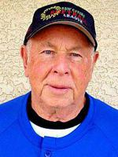
Keller, Ray (1933 – 2020)
RAY KELLER, long-time baseball player in Sun City passed away on November 29, he was 87. I spoke to Ray’s daughter, Sandy who told me that he had been having various medical issues over the past few years. Our pastor Bob was with him at the end. Ray played til the 1980’s with the Sidewinders and other teams during his long softball career.
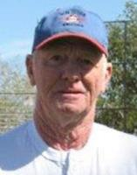
Klingensmith, Dallas W. (Red) (1934 – 2010)
Red Klingensmith, passed away on March 1, 2010 of brain cancer at the age of 75. He will be greatly missed by his loving wife of 55 years, Barbara; sons: Dale and Jerry; daughter, Sherrilyn; 5 grandchildren; and 4 great-grandchildren. Red worked at J&L Steel in Louisville, Ohio for 38 years then retired to Sun City, AZ where his favorite pass time was playing Senior Softball for the last 11 years. There will be no public service. Any contributions will be forwarded to Sun City Senior Softball Club and Angels in the Outfield.

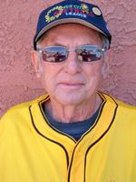
Letko, Steve (1929 – 2020)

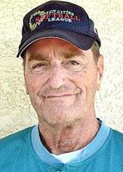
Lince, Bill

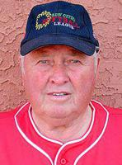
Markel, Jack

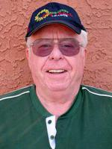
McGuire, Jim

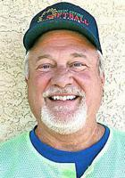
McGuire, John (1951 – 2020)
John C. McGuire died in Sun City West, Arizona from complications of Covid-19. He grew up in Bothell, lived in Snohomish, and moved to Sun City West after 38 years of service at Boeing.
John is survived by his loving wife, Tracy McGuire; parents Bob & Annette McGuire, children Jack (Leah), Rachel (Shawn), Catherine (Aaron), and Andrew (Mariana); sister Patty (Leslie) and numerous grandchildren. He was preceded in death by his brother Bob. Due to Covid-19 there will be no service. We will miss his loving kindness, playfulness, and humor. Please stay safe and protect your loved ones!

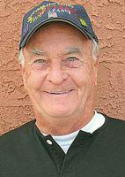
McKenna, William "Bill” (1934 – 2020)
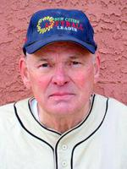
Miller, Spud

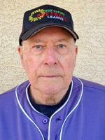
Milslegel, Bob

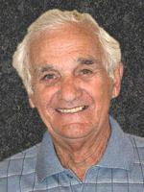
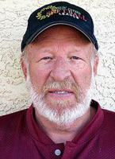
Mueller, Ernie (1927 – 2021)
Received info that ERNIE MUELLER, 93, has passed away from complications with Covid-19.
Mutton, Dave

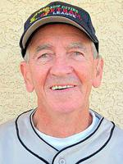
Nash, George (1937 – 2018)

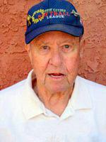
Oliver, Bill

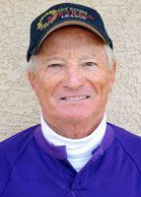
Ostrow, Ozzie (1934 – 2017)
Ostrow, Alvin "Ozzie" age 83 of Burnsville, MN. and Sun City West, AZ, succumbed to a 10 week battle with acute myeloid leukemia on June 30, 2017, with courage and dignity. Ozzie served his country for two years in the Army. He was a court reporter for 30 years in Hennepin County and was a USSSA umpire for 24 years with Parks and Recreation. He played 20 years of Sun City West Senior Softball, where he made many friends. He also enjoyed woodworking and gardening. Ozzie was preceded in death by parents, Julius and Tressa Ostrow. He is survived by beloved wife of 59 years, Laurell; daughter, Julie (Bill) Shea; grandchildren, Maria and Matthew Shea; sister, Donna Johnson; sisters-in-law, Beverly Fries (SSND) and Lavern (Tom) Rhode and many beloved nieces and nephews. Memorial service will be held at 11:00 a.m. on Thursday, July 6, 2017 at Cremation Society of Minnesota, 7110 France Ave. S., Edina. Visitation one hour prior to service. In lieu of flowers, memorials preferred to N.C. Little Memorial Hospice of Edina or Park Nicollet Methodist Hospice. Private interment, Fort Snelling National Cemetery.

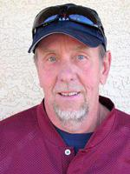
Ottenbreit, James "Jim” (1955 - 2013)
Jim Ottenbreit passed away suddenly following a heart attack doing what he enjoyed, Golfing in Sun City West, Arizona on March 27, 2013 at the age of 58 years. Jim was born in Revelstoke on March 11, 1955; he made this his lifetime home. He is well remembered and respected for his years of dedication with his construction company, Jim's Stucco and Drywall. He worked hard and played hard, his favorite sports being golf, bowling, skiing, hockey, hunting, fishing, but most of all lived to play baseball, and was a great friend to all.
The Mass of Christian Burial was held from St. Francis of Assisi Catholic Church on Saturday afternoon, April 6th, at 1 p.m. with Father Aaron de Dios the celebrant. The eulogy was shared by his children, Diane and Darren. Interment followed in Mountain View Cemetery with pallbearers, Mike Loukopoulos, Peter Bernacki, Stewart Defeo, Albert Van Goor, Robert Menzies, Russell McKenzie, George Marshall and Larry Parsons. A reception, catered by the Catholic Women's League, followed back at the recreation center, allowing time to share memories with family and friends, including the presentation of a DVD.
Jim was predeceased by his parents, John and Mary Ottenbreit. He leaves his loving family, wife, Sharon, daughter Diane (Stephen) Bull of Revelstoke; son, Darren of Invermere, two grandchildren, Lane and Mackenzie Bull; sisters, Margaret Menzies of Williams Lake, Josephine Hawker (Don) of Revelstoke and brother David (Deenie) of Revelstoke. Email condolences may be sent to Jim's obituary at www.brandonbowersfuneralhome.com Funeral arrangements were in the care of Brandon Bowers Funeral Home, Revelstoke.

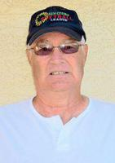
Power,Ron

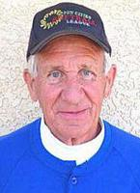
Primnow, Roger
Roger, 80. Survived by wife Jeanne, sons John (Debra) Pribnow, David Pribnow, daughter Jane (Curt) Chase and seven grandchildren. Celebration of Life service at Grace Church, 1310 County Road B2 West, Roseville, MN on Friday, June 14. 10:00 visitation, 11:00 service.
Published in Pioneer Press on June 9, 2019
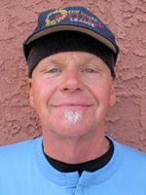
Ritzman, Ed (1943 – 2014)

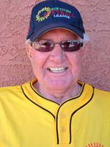
Rowland, Wayne

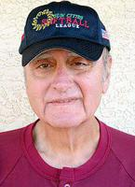
Scuderi, Bob (1946 – 2017)
Husband, father, uncle, grandfather and friend joined God and his Heavenly Family for a great reunion. He was born in New York City to Sam and Mary Scuderi on November 2, 1946. Bob spent his childhood and early life in New York until he joined the Air Force at the age of 17 and served in Vietnam before eventually being assigned to Fairchild AFB. This is where he met the love of his life, his wife Maureen. During their 48-year marriage they had two wonderful children Ross and Kristi and three handsome grandsons Andrew, Blake and Sam. Bob was a long-time employee at Sears as a custom decorator and will be remembered by many of his clients. Bob and Maureen made many of us jealous and enjoyed many winters in Sun City West, AZ. This is where Bob rekindled the second love of his life- senior league softball. In fact, there's a good chance he's involved in a double header right now.

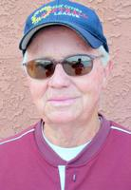
Stolp, DeLos “Del” (1931 – 2020)
Watertown, SD - DeLos Dae Stolp, 88, formerly of Watertown, SD, passed away on May 1, 2020 in Sun City, AZ. There will be no service. DeLos was born on July 11, 1931 to Ralph and Bessie (Erickson) Stolp and grew up on the family farm west of Hayti, SD. He married Phyllis Robish in 1948, and in 1950 joined the South Dakota National Guard. Delos and Phillis had six children before the marriage ended. He enlisted for active duty in the U.S. Army in 1958. He then married Helen Terrier and had three more children.
He served two tours in Vietnam as a Sniper and a Sniper instructor. He won numerous competitions and awards as a member of the National Army Rifle Team. His commendations include: National Defense Service Medal, Combat Infantryman Badge, Army Commendation Medal, Vietnam Service Medal, Bronze Star Medal, Good Conduct Medal, Vietnam Campaign Medal w/60 DEV, Vietnam Cross of Gallantry w/Palm, Meritorious Unit Citation and three Overseas Bars. DeLos was honorably discharged from the Army in 1976.
In 1996 he married Zenaida Mier and they lived most of their married life in Sun City, AZ. He is survived by his wife and nine children: Jimmy, Dennis, Richard, Jerry, Donita, Colita, DeeAnne, Bob and Jackie. He was also survived by 30 grandchildren, 115 great-grandchildren and 20 great-great grandchildren; his brothers Orvis, Gordon, Gary and his sister Judy and many nieces and nephews.
He is preceded in death by his parents and his brother, Curt.
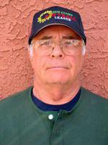
Stone, Roger

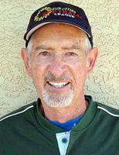
Sutter, Gene Marlyn (1931 – 2021)
GENE SUTTER, 89, of Sun City West, Arizona, a long-time member of our Softball Club passed away to be with his Lord and Savior Jesus Christ on January 14, 2021 from Lung Cancer.
He was born in Delavan, Illinois, on November 24, 1931 to parents Ervin and Marie (Litwiller) Sutter. He married Anna Birky on November 9, 1957, and they had two children: Clark Suter of Phoenix, Arizona and Lizanne Sutter of Peoria, Arizona. He served as a medic during the Korean War, and then attended business college, which let him to owning Dairy Queen franchises in Illinois and Arizona. He was preceded in death by his parents, one brother, and Anna, his wife of 58 years. Gene enjoyed playing softball with the Senior Olympics in Sun City, Arizona. Gene was quite the athlete over his many ball playing years. He was a Senior Olympic Medalist and was a Golden Glove recipient from the Arizona Diamond Back organization. He enjoyed bike riding and traveling with Anna, Lizanne and Clark. He also enjoyed many trips, both local and overseas, with close friends.

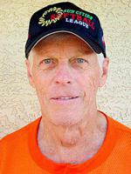
Szromba, Lee (1936 – 2017)
Lee Szromba, age 81, passed away on April 30, 2017. He was born on July 7, 1936. No other information is available.

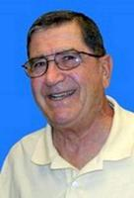
Szydlowski, Matt ( – 2015 )
Matt Szydlowski was very dedicated to the community and served in many capacities over his 25 years here. He was a member of the Governing Board from 2006-2008 and served two terms as president in 2007-2008. In addition, he was chairman of the Human Resources Committee in 2006 and served as Chartered Clubs Liaison many times over a period of nearly 20 years.
Matt was active in many of the Sun City West’s Chartered Clubs over the years as well, including the Sun Cities Senior Softball League, where he played, managed, and served three stints on the board and two terms as league present. Szydlowski was inducted into the League’s Hall of Fame in 2000.

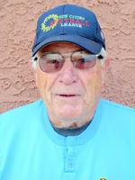
Tramel, Jim

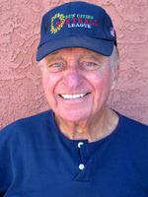
Venturelli, Frank (1929 – 2014)
Frank Venturelli, 85, of Sun City West, AZ died peacefully with family at his side on December 12, 2014. Frank was born in St. Louis, MO, and graduated from Hillsboro High School in Hillsboro, IL class of 1946. After serving in the Marine Corps, Frank studied at the University of Illinois, Marquette University, and the Milwaukee Institute of Technology. He worked as an industrial engineer with General Electric, American Motors, and Hotpoint before becoming plant manager for Advance Transformer in Platteville, WI and Ciudad Juarez, Mexico.
Frank was a natural leader and a truly genuine, caring man who endeared himself to many with his outgoing, colorful personality. Frank retired to Arizona in 1996 and remained very active during retirement. His many interests and hobbies included softball, golf, bocce ball, and bible study. He was also an accomplished Toastmaster and thespian.
He was preceded in death by his son Mark and grandson Francisco and is survived by his wife of 64 years, Dolores (Petroske) Venturelli, his son Ron of Peoria, AZ, and daughters Donna of Janesville, WI, and Mary Jo of Phoenix, AZ as well as three grandchildren and two great-grandchildren. He will be dearly missed by them and countless others.
Published in Daily News-Sun on Dec. 17, 2014

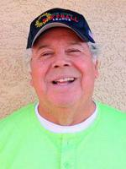
Videl, Ray (1942 – 2017)
Ray M. Vidal, 74, passed away peacefully at Sherman Hospice Home on Feb. 13, 2017 after a struggle with melanoma cancer. Ray was born in Los Angeles, CA. the youngest of 5 children of Lucio and Esperanza Vidal.
Ray retired from the US Postal Service after 35 years as a letter carrier. He retired again from the Paradise Valley school district where he was a bus driver for special needs children.
Ray was preceded in death by his parents, brother Rudy, sister Laura and stepson… Erik. He is survived by his wife Merrikay and their blended family: daughters, Sherri (Don) Lockwood, Heidi (Larry) Weis and son Brad (Kathy) Thompson. Grandchildren, Rachal, Benjamin, and Ashley. Also surviving sisters Aurora (Dora) Altamirano and Ophelia Ehart. Nieces: Veronica Vidal, Sylvia (Scott) Gissel, Amelia Altamirano, Carolyn Rivera, Dena (Juan) Barragan. Nephews: Rudy Vidal Jr., Ricky Vidal, Steve Altamirano Sr., David Altamirano, Bobby Ehert.

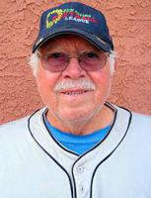
Vitale, Paul

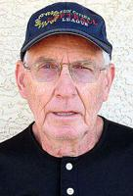
Welch, Frank (1931 – 2021)
FRANK P. WELCH March 15, 1931 – May 1, 2021
Frank P. Welch, 90, of Sun City West, AZ, and Los Alamos, NM, passed away peacefully in his sleep at home May 1, 2021.
Frank was born in Davenport, Iowa, March 15, 1931, and was one of 8 children. The family business was a successful local gas station and Frank and his brothers all helped out there. Frank attended St. Ambrose College in Davenport and earned a degree in Accounting.
He was preceded in death by his infant son Mark Stephen Welch, his parents Archibald and Josephine Welch, his sister Margaret Herold and his brothers John and Michael Welch.
On a drive to visit an uncle in Colorado one summer Frank realized that his asthma improved dramatically. That trip to the higher elevation and drier air of the West was when he first experienced being able to take a full breath! Frank’s uncle suggested that he visit a cousin in Los Alamos, New Mexico, and Frank liked the town – and the air – so much that he wanted to stay. He finished his studies at St. Ambrose and then headed back to Los Alamos to work.
Los Alamos was a small, but vibrant, post-war government town back then, with many young professionals and social activities. A few years after coming to town.
Frank met a young nurse named Mary V. Milliken (Ginger), and the two formed a bond that continues today. They were married on June 18, 1960, and Frank became a lifelong member of the “I Married a Milliken” club. They stayed in Los Alamos another 35 years, raising their family and working.
Frank was a dedicated career employee at the Los Alamos National Laboratory (the “Lab”), working in various accounting and business areas. He was very involved in the early Lab business computing systems, and he was instrumental in the Lab transition to desktop computing. He earned an MBA degree and managed several key data processing operations.
Frank was also a valued member of the Los Alamos community. He was on the board that initiated the building of Barranca Mesa Pool, he was a longtime supporter and board member of the Los Alamos Aquatomics Swim Team, and he volunteered as a Y-Indian Guides leader and a Grey Y football and basketball coach. He was a dedicated parishioner, council member and catechism teacher of the Immaculate Heart of Mary Church.
Frank was diagnosed with asthma at an early age, but he found his true calling as an athlete (his nickname was “Bullet”) once he moved to the clear air of the Southwest. He loved skiing, golf, softball, tennis, hiking, and track. Frank supported all his children in all their athletic (and non-athletic) endeavors. He was on the Senior Olympics 800-meter world record-breaking relay team in 1992. When he retired and moved to Sun City West, Arizona, he pursued his athletic dreams – Senior Olympics, tennis, and playing softball for 20 years. In Sun City West he was also very involved as a dedicated parishioner and council member of the Lord of Life Lutheran Church.
Frank loved traveling with his family. With a carload of children, he made trips to the Midwest and Elmira, NY, and he loved hosting the annual family reunion in Angel Fire, NM. He also enjoyed taking wonderful trips around the globe with his children and his brothers and sisters.
Frank is survived by Ginger, his wife of 61 years, and their 5 children, Kathie Wright (Orbry), Bill Welch (Chi), Frank Welch (Michael), John Welch (Micaela), and Tim Welch (Bridget). He was “Papa” to his 12 grandchildren [Sarah Nelson (Nate), Betsy Rodriguez (Raul), Becca Wright (Greg), Christopher Welch, Abbie Wright, Ceara Melton (Kyle), Margaret Cardiel (Mateo), Patrick Welch, Josh Scheel, Mark Welch, Kelly Welch, and Ava Welch] and his 6.5 great-grandchildren [Raegan, Colin, Leo, Emi, Ellison, Skylar, and Maddox]. He is survived by his sisters Mary Peeters, Sally Tueckes (Mac), and Sue Murphy (John); his brother Bill Welch (Lucille); and his many, many cousins, nieces, nephews, and friends. Frank’s kindness, humor, grace, and warm heart will be missed by us all.
There will be a service at Lord of Life Church in Sun City West, AZ, at 11 a.m., June 19, 2021, and a service at Immaculate Heart of Mary Parish in Los Alamos, NM, at 10 a.m., July 10, 2021. In lieu of flowers, any memorial donations can be made to the charity of your choice, or to:
Benedictine Mission House,
Africa School Project for Father Damian
P.O. Box 528
Schuyler NE 68661-0528

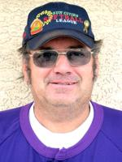
Wells, Richard “Tex” (1946 – 2021 )
Richard C. Wells (Tex), 74, of Sun City West, AZ passed away unexpectedly on Wednesday January 13, 2021, due to Covid-19 complications. Richard was born in Mauston, WI and grew up on the family farm. He was raised by his hardworking parents Chester and Lillian. He played sports throughout his high school years, but his favorite was baseball. This was his passion in life, playing ball as he would say.
He joined the Air Force after graduating high school and was stationed at Randolph Air Force Base, San Antonio TX. In May 1969 he married and during this union he had 2 daughters, Rebecca and Rachelle. After his service he moved to Aurora, CO in 1970. He was employed with Colorado Dept of Transportation where he was a Structural Engineer until his retirement. He moved to Sun City West, AZ in 2000 to enjoy the weather and be able to play softball all year long. He played on multiple softball teams each season and loved every moment. When he was out playing ball, he was having the time of his life. In between softball seasons he loved to travel the United States and visit family and explore many of the National parks. He was an avid hunter and fisherman in his younger years and as time went by, he enjoyed bird watching from his backyard and going for evening drives in his golf cart. He was a man that could start a conversation with anyone, loved helping his community and had a recognizable laugh that we will never forget.
He is preceded in death by his parents Chester and Lillian Wells and his sister Darlene and nephew Timothy. He is survived by his two daughters Rebecca (Ryan McComas) and Rachelle (Brendan Green). Two grandsons Garrett and Hudson Green. His siblings Donna (John Wayne), Duane (Cindy) and Don (Sandy) and many nephews and nieces.
Friends and Family who wish to Honor Richard can make a donation to the Humane Society.
A private memorial will be held at a later time.

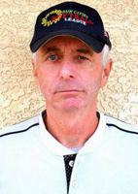
Wenners, Bob (1946 – 2010)
Bob was born August 28, 1946 in Quincy, Massachusetts - moving to Southern California as a child where he lived until coming to Arizona several years ago. Bob served as a Navy Corpsman attached to a Marine unit in Vietnam, thankfully returning home safely from his service to his country. He worked a long career as a retail executive before spending an entire second career working as an administrator at a wild animal sanctuary in Southern California. Bob and Diana met in 1986 and married in 1990 in Lake Tahoe, Nevada. They fulfilled an almost 20 year dream of living in Arizona when they moved here in May 2005. They fell in love with Sun City West where Bob's first wish after recuperating from knee surgery that year was to explore playing softball with the Sun Cities Senior Softball League. He took a flexible job at Safeway which gave him the freedom and time to pursue that softball dream. He played ball 6 days a week up until his illness slowed him down last Spring and even then, kept coming out to the field to practice when he could and spend time in the bleachers with his softball brothers when he wasn't up to playing. Bob treasured the friends he made here and the softball family was a huge part of that group of friends. In addition to Diana and Australian Shepherds Lakota and Kiowa, plus an incredible group of friends here and across the country.
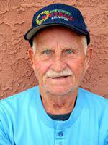
Worley, Walt (1928 – 2013)
Walter of Sun City, AZ and a former longtime resident of Elyria, left this life and went home to his “field of dreams” June 24, 2013. He was born May 31, 1928 in Wilder, TN, and served with the U.S. Army from 1945 to 1946. He was employed at Harshaw Chemical Company in Elyria for 38 years, retiring in 1990 Walter was a member of Elyria American Legion Post 12 and enjoyed fishing and golf. After moving to AZ in 1994, he played softball with the Sun City Seniors League, where he received the award as Most Valuable Player.
Walter is survived by a son Lyn A. Worley of Lake Station, IN and daughter Dawn M. Day of Mesa, AZ; 6 grandchildren; 13 great-grandchildren and 3 step grandchildren.
He was preceded in death by his first wife Nancy A. Worley (nee Williams) in 1999; second wife Fran Worley; brothers William A. Worley, Jr. in 2012 and Forest E. Worley in 1950; sisters Nannie Ray, Marie Drake, Grace Smith, Ruby Marrow Thomas and Agnes Smith and a grandson Dustin M. Worley in 1981.

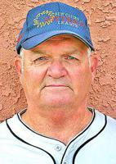
Zeppa, Ben (1942 – 2021)
BEN ZEPPA, Sun City Softball player and 2019 Hall of Fame recipient passed away, May 18, after a sudden diagnosis of Cancer. Ben was born on September 30, 1942. He was a very active person with the Club, managing for 7 years various teams, board member of Sun Cities Club and a Green Team evaluator. He loved playing softball and the many friends that he met during his Softball years. Talking with his wife, Diane, I learned that he was a former singer in his younger days. There will be no service at this time. Our prayers and thoughts are with the family. The family would appreciate any cards or thoughts sent to: Diane Zeppa 9718 W. Mockingbird Dr. Sun City, AZ 85372.
Ben Joe Zeppa was a United States Marine Corps veteran. He proudly served his country in the United States Marine Corps from 1959 to 1963. Lance Corporal Zeppa was trained as military occupational specialty 2511 Wireman. Typical duties involved running communication lines and wires usually serving at battalion capacity. Lance Corporal Zeppa served 10 months and 26 days in foreign service in Japan. Ben Joe Zeppa was released from active duty and honorably discharged in September 1963. While in the service of his country Lance Corporal Zeppa earned the Good Conduct Medal 2nd award.
It is our honor to stand in silent reverence as we show respect and gratitude to this hero for his sacrifices made for this nation.

